Raffle Numbers Python Game

Description
This code is a simple raffle numbers selection and animation program, written in Python with the Kivy Framework. Kivy is an open-source, cross-platform Python framework designed for developing applications with graphic user interfaces.
The Raffle Numbers program has been written with the intention to package the application into an Android Application with the Buildozer build framework, for it to be available on the Google Play store. After much effort, it was found that the Buildozer builder failed to package the code into an apk file successfully. Regardless, the Raffle Numbers program was built, compiled and tested on both Windows 10 and Ubuntu Linux operating Systems successfully.

Code Repository
All code and documents relating to the Raffle Numbers game can be found on Github at:
https://github.com/zzab68/bazzraffle/tree/main

Screenshots of Game

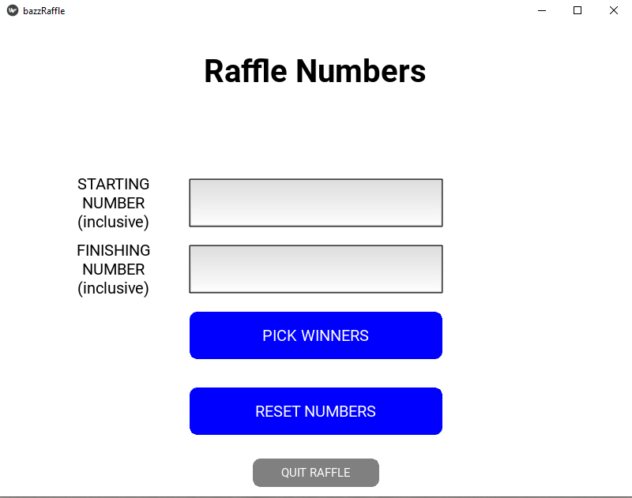
Figure 1 The Raffle Numbers Intro Screen
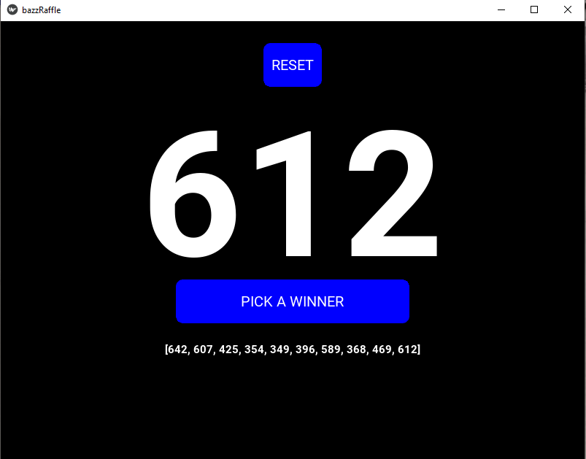
Figure 2 The Draw Raffle Numbers Screen
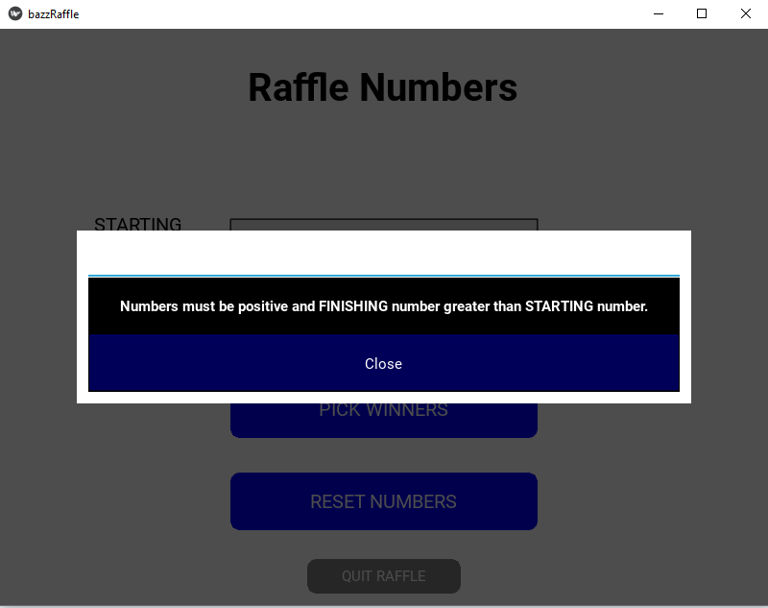
Figure 3 An error is encountered with number entry
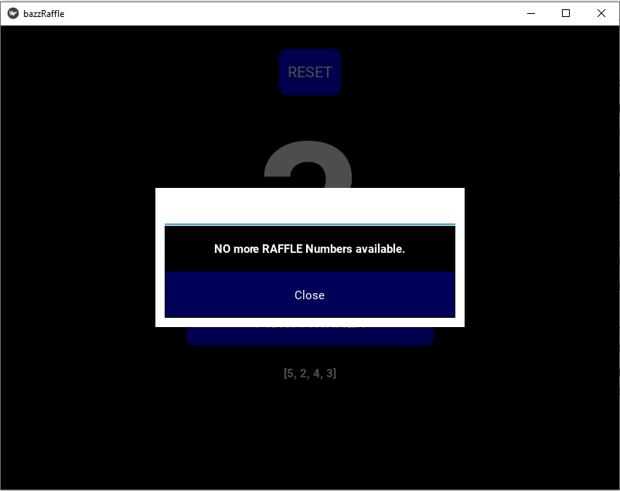
Figure 4 Raffle Number Range is depleted

Pseudocode Flowchart
The Raffle Numbers Flowchart (Figure 5) displays the process required to execute the program correctly.
The flowchart indicates which checks are made on varioius user input data, as well as logic issues such as all numbers have been chosen in the Raffle Number range, and finishing Raffle Number is less than or equal to starting raffle Number.

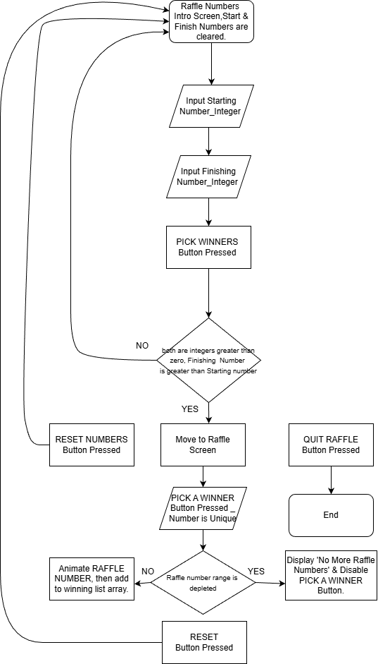
Figure 5 Pseudocode Flowchart of game logic

Code Verification Table
Testing of the Raffle Numbers game was undertaken on Windows and Linux Operating Systems successfully.
The raffle Numbers Game was not able to be packaged into an Android .apk file as was the initial intention of this project, to give a ‘master of ceremonies’ a raffle game on their phone that could be displayed on a nearby LCD screen.
The following table displays test procedures undertaken to confirm correct game logic and valid user input is checked for the Raffle Numbers game:
Test No. | Description | Expected Result | Actual Result | Pass/  Fail | Tested  who/when
1 | Start number entered | Number entered is an integer greater than 0. | Negative number or non-integer numbers disallowed; correct error pop-up message appears.
2 | Finish number entered | Number entered is an integer greater than 0 and greater than start number. | Negative number, non-integer or number less than or equal to starting number unaccepted. Correct error pop-up message appears.
3 | Pick winner button pressed | Random number generated by program between start and finish numbers inclusive, MUST be unique number. Continue until all numbers including start and finish are selected at random (e.g., use a small raffle numbers window.) | Each raffle number generated and displayed is unique; start and finish number are included in this list.
4 | Winning raffle numbers list | Current winner raffle number is added to list, the list displayed on screen | Each raffle number is added to winning numbers list, only after success from Test 3 ‘Pick winner’.
5 | No raffle numbers left, end of raffle | Notification when all numbers in raffle range are exhausted (available numbers <1). | Correct error pop-up message appears when all raffle numbers are chosen.
6 | Clear numbers button pressed | Clears input text boxes | Start number, finish number boxes are cleared.
7 | Reset number pressed | Raffle ‘pick Winners screen’ ends | Control returns to initial ‘Enter Numbers’ screen, all boxes are cleared, all variables reset to 0.

Code

File: main.py
###############################################################################
# RUN MAIN #
###############################################################################
# setup
import warnings
warnings.filterwarnings("ignore")
import math
import random
import kivy
from kivy.factory import Factory
from kivy.lang import Builder
from kivy.uix.screenmanager import ScreenManager, Screen, FadeTransition, SlideTransition
from kivy.uix.image import Image
from kivymd.app import App
from kivy.core.window import Window
from kivy.uix.floatlayout import FloatLayout
from kivy.uix.textinput import TextInput
from kivy.clock import Clock
from functools import partial

# Global variables in Python, similar to public/private static final.
# SHUFFLE_DURATION_COUNTER x SHUFFLE_ANIMATION_GAP = Total Shuffle Time, in Seconds.
SHUFFLE_ANIMATION_GAP = 0.1 # how long between the number shuffled on screen, in Seconds.
SHUFFLE_DURATION_COUNTER = 20 # How many times the shuffle occurs.

# Load the KV file
Builder.load_file('components.kv')

# screens
class IntroScreen(Screen):
start_raffle_number = 0
finish_raffle_number = 0
max_numbers = 0
finish_number_length = 0
def start_raffle(self, *args):
# First up, perform all error checking on the Raffle numbers before progressing.
# Start abd Finish Raffle numbers must be greater than 1 and finish_raffle_number > start_raffle_number.
if not self.ids.start_number.text:
#print(" ERROR = start_number Text box is empty.")
Factory.NumberEntryError().open()
return
else:
#print(" start_number Text box contains content.")
IntroScreen.start_raffle_number = int(self.ids.start_number.text)
if IntroScreen.start_raffle_number <1:
#print("ERROR = start_number is less than 1.")
Factory.NumberEntryError().open()
return # This exits the my_kivy_method function
if not self.ids.finish_number.text:
#print(" ERROR = finish_raffle_number Text box is empty.")
Factory.NumberEntryError().open()
return
else:
#print(" finish_number Text box contains content.")
IntroScreen.finish_raffle_number = int(self.ids.finish_number.text)
if IntroScreen.finish_raffle_number <1:
#print("ERROR = finish_integer is less than 1.")
Factory.NumberEntryError().open()
return # This exits the my_kivy_method function
if IntroScreen.start_raffle_number >= IntroScreen.finish_raffle_number :
#print("ERROR = FINISHING NUMBER must be greater than STARTING NUMBER.")
Factory.NumberEntryError().open()
return # This exits the my_kivy_method function
else:
# The max_number must include start and finish number.
IntroScreen.max_numbers = IntroScreen.finish_raffle_number - IntroScreen.start_raffle_number + 1
# This sets big number display digit length equal to finish numbers digit length.
IntroScreen.finish_number_length = int(math.log10(IntroScreen.finish_raffle_number)) + 1
"""
print(f'STARTING NUMBER is {IntroScreen.start_raffle_number}')
print(f'FINISHING NUMBER is {IntroScreen.finish_raffle_number}')
print(f'MAX RAFFLE NUMBERS is {IntroScreen.max_numbers}')
print(f'IntroScreen.finish_number_length is {IntroScreen.finish_number_length}')
"""
formatted_number = str('0').zfill(IntroScreen.finish_number_length)
# The next line sets the big RAFFLE number to zeros with digit length equal to finish numbers digit length.
self.manager.get_screen('main_screen').ids.displayed_raffle_number.text = f"{formatted_number}"
self.manager.get_screen('main_screen').ids.pick_winner_button.disabled = False
self.manager.transition = SlideTransition(direction='left')
self.manager.current = 'main_screen' # change screens here due to logic; the kv file can't do logic for transitions.

def reset_nums(self):
self.ids.start_number.text = ''
self.ids.finish_number.text = ''

class MainScreen(Screen):
# Initialize an empty list to store raffle numbers
unique_raffle_numbers = []
unique_raffle_numbers.clear()
count = 0

# This method updates the BIG SHUFFLED RANDOM number Label displayed_raffle_number.
def update_main_raffle_number(self):
formatted_finish_number = str(self.new_random_number).zfill(IntroScreen.finish_number_length)
self.ids.displayed_raffle_number.text = f"{formatted_finish_number}"
#print(f"new_random_number inside update_main_raffle_number = {formatted_finish_number} ")
self.ids.drawn_raffle_list.text = f"{self.unique_raffle_numbers}"

# This method updates the list of drawn raffle numbers with the new number.
def update_raffle_list_display(self):
self.ids.drawn_raffle_list.text = f"{self.unique_raffle_numbers}"

def clear_Raffle_array(self):
self.unique_raffle_numbers = []
self.unique_raffle_numbers.clear()
self.ids.pick_winner_button.disabled = False

def start_animation(self):
self.count = 0
self.event = Clock.schedule_interval(self.animate_text, SHUFFLE_ANIMATION_GAP)
# Schedule the stop event after the shuffle duration.
#Clock.schedule_once(self.stop_animation, SHUFFLE_DURATION_TIME)

def animate_text(self, dt):
"""Called every 0.1 seconds to add a new character."""
self.count += 1
fake_random_number = str(random.randint(IntroScreen.start_raffle_number, IntroScreen.finish_raffle_number))
formatted_fake_number = str(fake_random_number).zfill(IntroScreen.finish_number_length)
#formatted_finish_number = str(self.new_random_number).zfill(IntroScreen.finish_number_length)
self.ids.displayed_raffle_number.text = f"{formatted_fake_number}"
#self.ids.displayed_raffle_number.text = f"{formatted_finish_number}"
#print(f" Fake random number = {fake_random_number}")
#print(f" formatted_fake_number = {formatted_fake_number}")
if len(self.unique_raffle_numbers) < IntroScreen.max_numbers:
if self.count >= SHUFFLE_DURATION_COUNTER:
self.update_main_raffle_number()
#self.update_raffle_list_display()
self.ids.pick_winner_button.disabled = False
self.event.cancel() # Stop the interval
#self.stop_animation(dt) # Stop the interval
else:
#self.count = 0
self.update_main_raffle_number()
#self.update_raffle_list_display()
self.ids.pick_winner_button.disabled = False
#print(f"IntroScreen.max_numbers Maximum Number = {IntroScreen.max_numbers} in animate_text.")
#Factory.RaffleFull().open()
self.event.cancel() # Stop the interval

# Generate a new random unique raffle number and add it to the unique_raffle_numbers list.
def generate_and_add_number(self):
self.ids.pick_winner_button.disabled = True
if len(self.unique_raffle_numbers) < IntroScreen.max_numbers:
while True: # Simulates a do-while loop
self.new_random_number = random.randint(IntroScreen.start_raffle_number, IntroScreen.finish_raffle_number)
#print(f"Random Number generated = {self.new_random_number} ")
if self.new_random_number not in self.unique_raffle_numbers:
self.unique_raffle_numbers.append(self.new_random_number)
break # Exit the loop once a unique raffle number is found and added
else:
#print(f"Maximum Number of {IntroScreen.max_numbers} in generate_and_add_number.")
# If we have exhausted all possible raffle numbers in the range, disply Popup and Disable PICK A WINNER button.
Factory.RaffleFull().open()
self.ids.pick_winner_button.disabled = True

class MyScreenManager(ScreenManager):
pass

class bazzRaffle(App):
def build(self):
sm = MyScreenManager()
Window.clearcolor = (1, 1, 1, 1)
sm.add_widget(IntroScreen(name='intro'))
sm.add_widget(MainScreen(name='main'))
return sm

########################## Run ##########################
if __name__ == '__main__':
bazzRaffle().run()

File: components.kv
#:kivy 2.3.1
<MyScreenManager>:
IntroScreen:
name: 'intro_screen'
MainScreen:
name: 'main_screen'

############################ INTRO SCREEN #######################################
<IntroScreen>:
canvas.before:
Color:
rgba: 1, 1, 1, 1 # white background for ScreenTwo
Rectangle:
pos: self.pos
size: self.size
FloatLayout:
Label:
text: 'Raffle Numbers'
bold: True
font_size: 40 # Set font size to 40 pixels
color: 0, 0, 0, 1 # Solid black text
size_hint: (0.1, 0.1)
pos_hint: {'center_x':0.5, 'center_y':0.9}

TextInput:
id: start_number
write_tab:False
canvas.before:
# Set the color of the outline (RGBA values)
Color:
rgba: 0, 0, 0, 1 # black
# Draw a rectangle for the outline
Line:
width: 1 # Thickness of the outline
rectangle: (self.x, self.y, self.width, self.height)
bold: True
font_size: 40 # Set font size to 40 pixels
color: 0, 0, 0, 1 # Solid black text
size_hint: (0.4, 0.1)
pos_hint: {'center_x':0.5, 'center_y':0.62}
text: ''
input_type: 'number' # Requests numeric keyboard
input_filter: 'int'
multiline: False # Ensures single line input

TextInput:
id: finish_number
write_tab:False
canvas.before:
# Set the color of the outline (RGBA values)
Color:
rgba: 0, 0, 0, 1 # black
# Draw a rectangle for the outline
Line:
width: 1 # Thickness of the outline
rectangle: (self.x, self.y, self.width, self.height)
bold: True
font_size: 40 # Set font size to 40 pixels
color: 0, 0, 0, 1 # Solid black text
size_hint: (0.4, 0.1)
pos_hint: {'center_x':0.5, 'center_y':0.48}
text: ''
input_type: 'number' # Requests numeric keyboard
input_filter: 'int'
multiline: False # Ensures single line input

Label:
text: 'STARTING NUMBER (inclusive)'
text_size: self.size
#bold: True
halign: 'center'
valign: 'middle'
font_size: 20 # Set font size to 40 pixels
color: 0, 0, 0, 1 # Solid black text
size_hint: (0.15, 0.3)
pos_hint: {'center_x':0.18, 'center_y':0.62}

Label:
text: 'FINISHING NUMBER (inclusive)'
text_size: self.size
#bold: True
halign: 'center'
valign: 'middle'
font_size: 20 # Set font size to 40 pixels
color: 0, 0, 0, 1 # Solid black text
size_hint: (0.15, 0.3)
pos_hint: {'center_x':0.18, 'center_y':0.48}

RoundedBlueButton:
id: Start_raffle_button
disabled: False
style: "filled"
#bold: True
font_size: 20 # Set font size to 20 pixels
text: 'PICK WINNERS'
size_hint: (0.4, 0.1)
pos_hint: {'center_x':0.5, 'center_y':0.34}
on_release:
root.start_raffle()
# root.manager.transition.direction = 'left' # Set transition direction
# root.manager.current = 'main_screen'
# Using app.root works when ScreenManager is the root widget of your application, but not recommended.
# app.root.transition.direction = 'left' # Override for this specific button
# app.root.current = 'main_screen'

RoundedBlueButton:
id: reset_numbers_button
disabled: False
style: "filled"
#bold: True
font_size: 20 # Set font size to 20 pixels
text: 'RESET NUMBERS'
size_hint: (0.4, 0.1)
pos_hint: {'center_x':0.5, 'center_y':0.18}
on_release:
root.reset_nums()

RoundedGreyButton:
id: Quit_App_button
style: "filled"
#bold: True
font_size: 15 # Set font size to 20 pixels
text: 'QUIT RAFFLE'
size_hint: (0.2, 0.06)
pos_hint: {'center_x':0.5, 'center_y':0.05}
on_press: app.stop()

############################ THE MAIN SCREEN #######################################
<MainScreen>:
canvas.before:
Color:
rgba: 0, 0, 0, 1 # Blue background for ScreenTwo
Rectangle:
pos: self.pos
size: self.size
FloatLayout:

RoundedBlueButton:
id: reset_button
style: "filled"
color: (1,1,1)
bold: False
font_size: 20 # Set font size to 20 pixels
text: "RESET"
size_hint: (0.1, 0.1)
pos_hint: {'center_x':0.5, 'center_y':0.9}
on_press:
drawn_raffle_list.text = ''
root.clear_Raffle_array()
root.manager.transition.direction = 'right' # Set transition direction
root.manager.current = 'intro_screen'

Label:
id: displayed_raffle_number
bold: True
font_size: 240 # Set font size to 240 pixels
color: 1, 1, 1, 1 # Solid black text
size_hint: (1, 1)
pos_hint: {'center_x':0.5, 'center_y':0.6}
text: '00'

RoundedBlueButton:
id: pick_winner_button
style: "filled"
color: (1,1,1)
bold: False
font_size: 20 # Set font size to 20 pixels
text: 'PICK A WINNER'
size_hint: (0.4, 0.1)
pos_hint: {'center_x':0.5, 'center_y':0.36}
on_press:
#root.generate_and_add_number()
root.start_animation()
root.generate_and_add_number()

Label:
id: drawn_raffle_list
bold: True
halign: 'center'
valign: 'middle'
text_size: self.width, None
#text_size: self.size
height: self.texture_size[1]
font_size: 15 # Set font size to 15 pixels
color: 1, 1, 1, 1 # Solid white text
size_hint: (0.5, None)
pos_hint: {'center_x':0.5, 'center_y':0.25}
text: ''

############################ DEFINE BUTTONS HERE #######################################

<RoundedBlueButton@Button>
background_color: (0, 0, 1, 0) # the last zero is important
background_normal: ''
border: (0,0,0,1)
canvas.before:
Color:
rgba: (0, 0, 1, 1) # Solid blue
RoundedRectangle:
size: self.size
pos: self.pos
radius: [10]

<RoundedYellowButton@Button>
background_color: (1, 1, 1, 0) # the last zero is important
background_normal: ''
canvas.before:
Color:
rgba: (1, 1, 0, 1) # Solid Yellow
RoundedRectangle:
size: self.size
pos: self.pos
radius: [10]
Color:
rgba: (0, 0, 0, 1) # black color for line border
Line:
rounded_rectangle: (self.pos[0], self.pos[1], self.size[0], self.size[1], 10)
width: 1.5

<RoundedGreyButton@Button>
background_color: (0, 0, 1, 0) # the last zero is important
background_normal: ''
canvas.before:
Color:
rgba: (0.5, 0.5, 0.5, 1) # Grey
RoundedRectangle:
size: self.size
pos: self.pos
radius: [10]

#:import Factory kivy.factory.Factory

<NumberEntryError@Popup>:
# Popup settings
#bold: True
#title: 'CHECK YOUR NUMBERS'
#title_align: 'center'
#title_color: 0, 0, 0, 1
#title_font: './font_file.ttf'
#title_size: sp(25)
#title_bold: True

#separator_color: 180/255, 164/255, 176/255, 1
#separator_height: dp(4)

#auto_dismiss: False

size_hint: 0.8, 0.3
background: ''
#background_color: 228/255, 216/255, 225/255, 1
background_color: 1, 1, 1, 1

# Content Area Settings
BoxLayout:
orientation: 'vertical'
canvas.before:
Color:
#rgba: 207/255, 190/255, 202/255, 1
rgba: 0, 0, 0, 1
Rectangle:
size: self.size
pos: self.pos

Label:
bold: True
text: 'Numbers must be positive and FINISHING number greater than STARTING number.'
color: 1, 1, 1, 1

Button:
text: 'Close'
background_color: 0, 0, 1, 1
on_release: root.dismiss()

<RaffleFull@Popup>:
# Popup settings
#bold: True
#title: 'CHECK YOUR NUMBERS'
#title_align: 'center'
#title_color: 0, 0, 0, 1
#title_font: './font_file.ttf'
#title_size: sp(25)
#title_bold: True

#separator_color: 180/255, 164/255, 176/255, 1
#separator_height: dp(4)

#auto_dismiss: False

size_hint: 0.5, 0.3
background: ''
#background_color: 228/255, 216/255, 225/255, 1
background_color: 1, 1, 1, 1

# Content Area Settings
BoxLayout:
orientation: 'vertical'
canvas.before:
Color:
#rgba: 207/255, 190/255, 202/255, 1
rgba: 0, 0, 0, 1
Rectangle:
size: self.size
pos: self.pos

Label:
bold: True
text: 'NO more RAFFLE Numbers available.'
color: 1, 1, 1, 1

Button:
text: 'Close'
background_color: 0, 0, 1, 1
on_release: root.dismiss()

############################ SPECIFIC BUTTON LOGIC #######################################
<BtnTextInput>:

# To position widgetsin the proper orientation
# use of vertical orientation to set all widgets
orientation: "vertical"

# Using the Box layout
#BoxLayout:
# height: "50dp"
# size_hint_y: None

FloatLayout:
size_hint: (0.2, 0.06)
pos_hint: {'center_x':0.5, 'center_y':0.4}

# Creating Test input
TextInput:
size_hint_x: 20

# Creating Button
Button:
text: "Apply"
size_hint_x: 25
background_color: 0, 0, 1, 1
font_size: 35

Author
All Python Code, including this document, was created and tested by Barry Smalldon 2025.

